INTEGRATION TESTING

Main Module: AdhocTicket.java

Import Classes:

* IAdhocTicket

Implemented Class:

* IAdhocTicket

Number of methods: 14 and one constructor

Tested Status:

|  |  |  |  |
| --- | --- | --- | --- |
|  | | **Testing Status** | **Bug** |
| **Modules** | AdhocTicket.java | Done | 2 error |
| **Implement Class** | IAdhocTicket.java | Done |  |
| **Import Classes** | IAdhocTicket | Done |  |

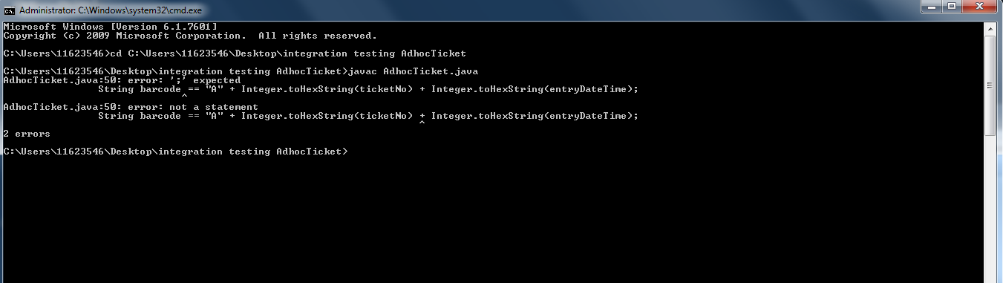

Prepared by: Rajinder Kaur